**Q1** The following are all the tables normalised form un with there following columns with their data type and Constrain

Trainer  
PK Trainer_ID Integer

Trainer_name varchar  
Trainer_Adress varchar  
Trainer Home Address varchar  
Trainer Country Address varchar  
FK CertificationID Integer

FK SchoolID Integer

gym class

PK GymClassID Integer Integer

GymClassName varchar  
GymClassLocation varchar  
FK SupervisorID varchar

School  
PK SchoolID Integer   
SchoolName varchar  
SchoolEmail varchar  
  
GymSupervisor

Gym SupervisorID Integer

Gym Supervisor Name varchar

FK CertificationID Integer

FK SchoolID Integer

Certification

PK CertificationID Integer

CertificationName varchar

CertificationDIsc TEXT

**Q2** Determine & list the primary keys – clearly identifying each related table

I think Trainer_ID, GymClassID, SchoolID, SupervisorID, CertificationID are all the primary keys we would be needing to make each table unique enough for 3NF.  
  
**Q3** Determine & list the foreign keys - clearly identifying each related table  
Just like primary keys, i think CertificationID,SchoolID, SupervisorID are the 3 Foreign key we need to make 3NF form workable.

**Q4** Determine the data types to be assigned to each data item captured – as shown APPENDIX A

Trainer_ID = Integer

Trainer_name = varchar  
Trainer_Adress = varchar  
Trainer Home = Address varchar  
Trainer Country = Address varchar  
CertificationID = Integer

SchoolID = Integer

GymClassID Integer = Integer

GymClassName = varchar  
GymClassLocation = varchar  
SupervisorID = varchar

SchoolID = Integer   
SchoolName = varchar  
SchoolEmail = varchar

Gym SupervisorID = Integer

Gym Supervisor Name = varchar

CertificationID = Integer

SchoolID = Integer

CertificationID = Integer

CertificationName = varchar

CertificationDIsc = TEXT  
  
**Q5** Determine and briefly explain **all** the relationships that will exist between tables in the database

Following relationship will exist b/w tables In the database

* Trainer with school and certifications
* Gym supervisors also with school and certifications
* Gym Class with Certification

**Q6** Create an entity relationship diagram for all tables showing the associations between each

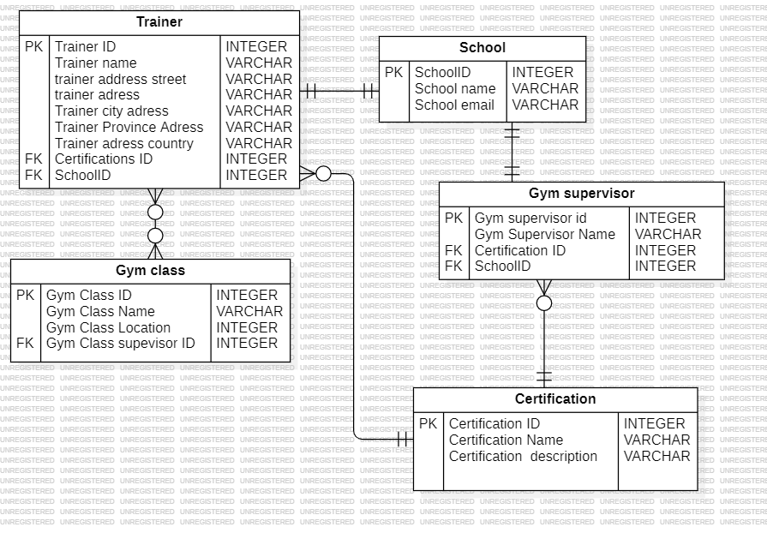  
This is the diagram :)

Mood enhancer question

Bonus:

**Q7** how did me and priyanka didNormalisation on The appendix 1 :)

First we take all the data and from appendix 1 and do logical reasoning on if from the information from Appendix 2. We tried to break down the data into 2 separate tables Trainer and Gym in 1st NF. for second form of NF we broke down GYM class into school and. For the 3rd NF form we broke down Trainers table into 3 tables which are Trainer, GYM Supervisor, Gym classes, schools and certifications.